**Elements Of Computing System - 1**

**End Semester Project** **Report**

*Submitted By:*

**Mettu Siddhartha- BL.EN.U4AIE21080**  **Group: E6**

*In partial fulfillment for the award of the degree*

Of

**BACHELOR OF TECHNOLOGY**

IN

**ARTIFICIAL INTELLIGENCE**



AMRITA SCHOOL OF ENGINEERING, BANGALORE

AMRITA VISHWA VIDYAPEETHAM

BANGALORE –560035

FEB 2022

**Faculty: Ms. Meena Belwal Date: February 16,2022**

**Question-1**

Implement the four Boolean functions listed using three half-adder circuits.

D = A xor B xor C

E = A'BC+ AB'C

F = ABC' + (A'+B') C

G = ABC

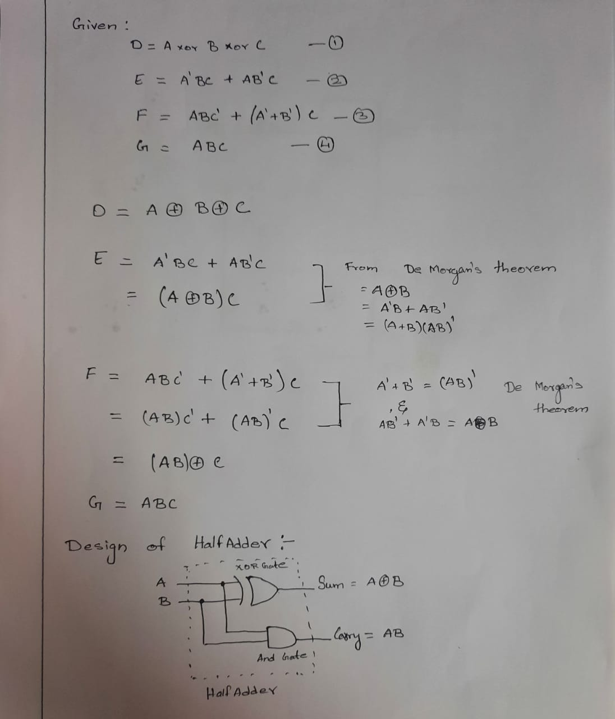

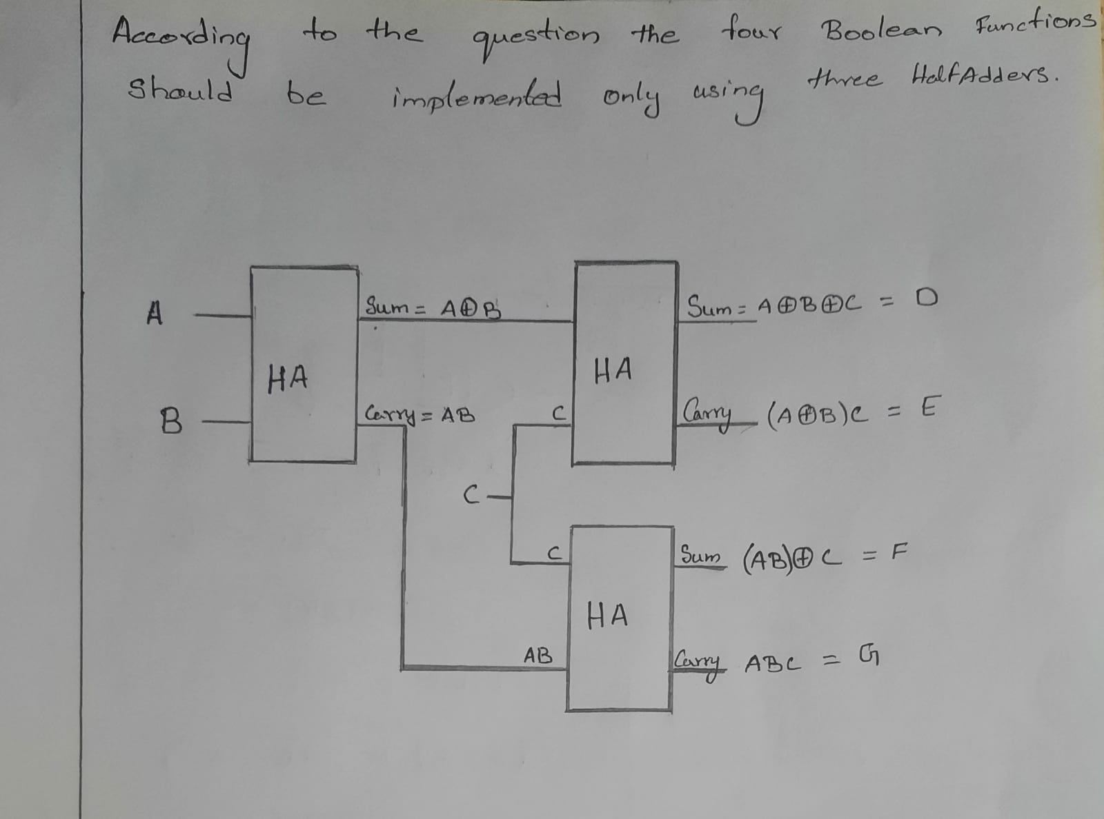

**Truth Table**

|  |  |  |  |  |  |  |
| --- | --- | --- | --- | --- | --- | --- |
| a | b | c | d | e | f | g |
| 0 | 0 | 0 | 0 | 0 | 0 | 0 |
| 1 | 0 | 0 | 1 | 0 | 0 | 0 |
| 1 | 1 | 0 | 0 | 0 | 1 | 0 |
| 1 | 1 | 1 | 1 | 0 | 0 | 1 |
| 1 | 0 | 1 | 0 | 1 | 1 | 0 |
| 0 | 1 | 0 | 1 | 0 | 0 | 0 |
| 1 | 1 | 0 | 0 | 0 | 1 | 0 |
| 0 | 1 | 1 | 0 | 1 | 1 | 0 |
| 0 | 0 | 1 | 1 | 0 | 1 | 0 |

**CODE:**

CHIP ThreeHalfAdders{

IN a, b, c;

OUT sum,

carry;

PARTS:

HalfAdder(a=a, b=b, sum=axorb, carry=ab);

HalfAdder(a=axorb, b=c, sum=d, carry=e);

HalfAdder(a=c, b=ab, sum=f, carry=g);

}

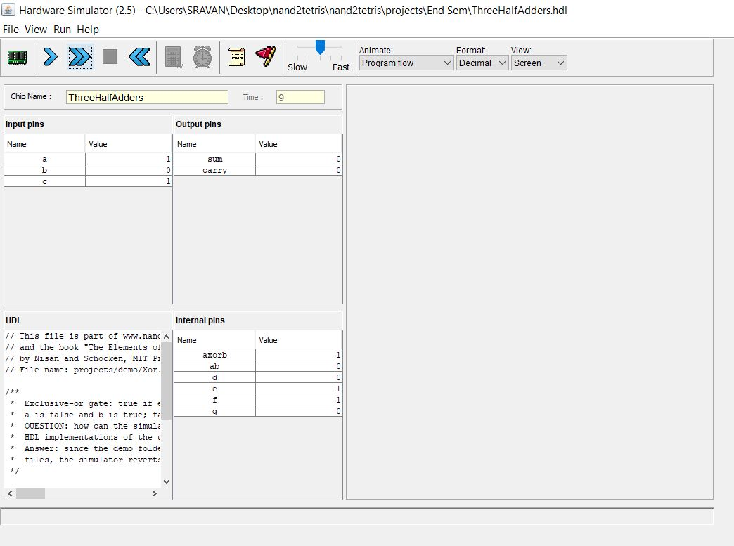

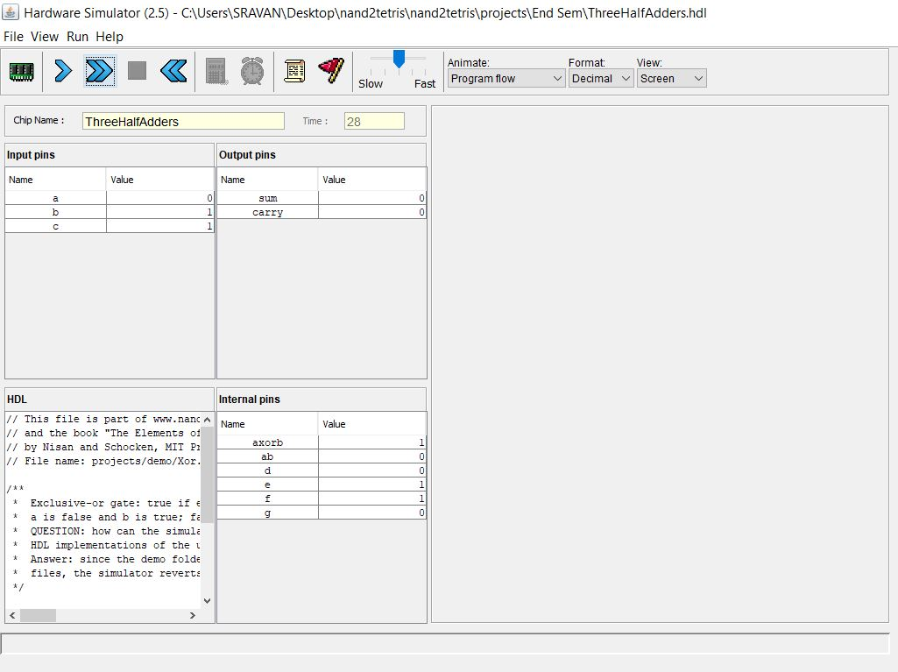

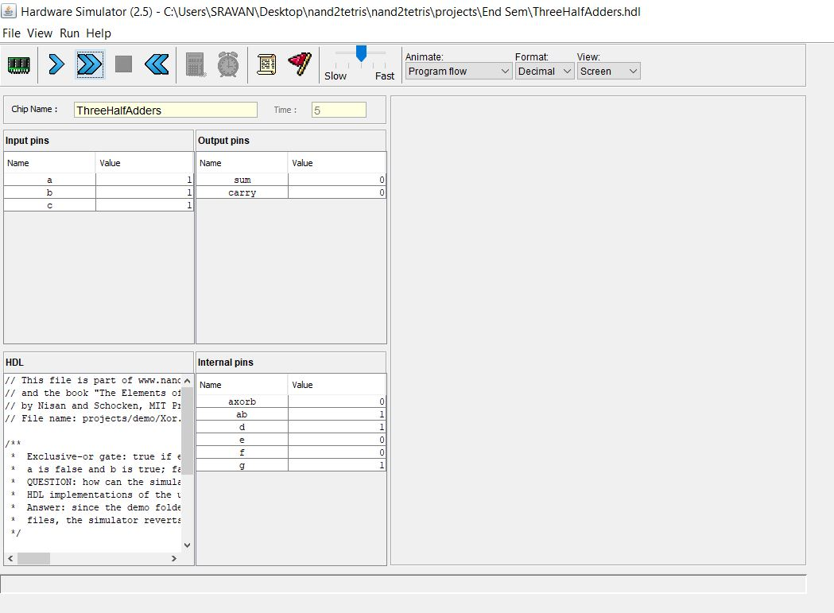

**Question-2**

Explain the 4-bit binary up counter. Implement it using T Flip Flop.

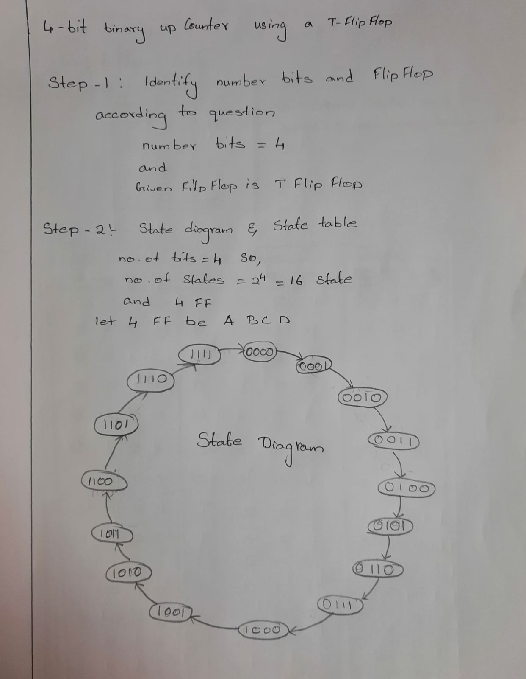

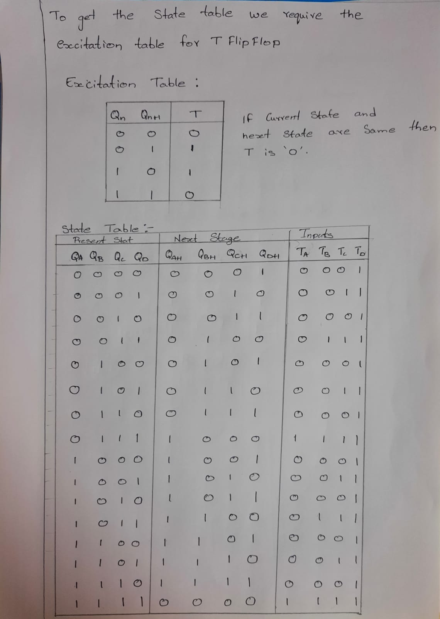

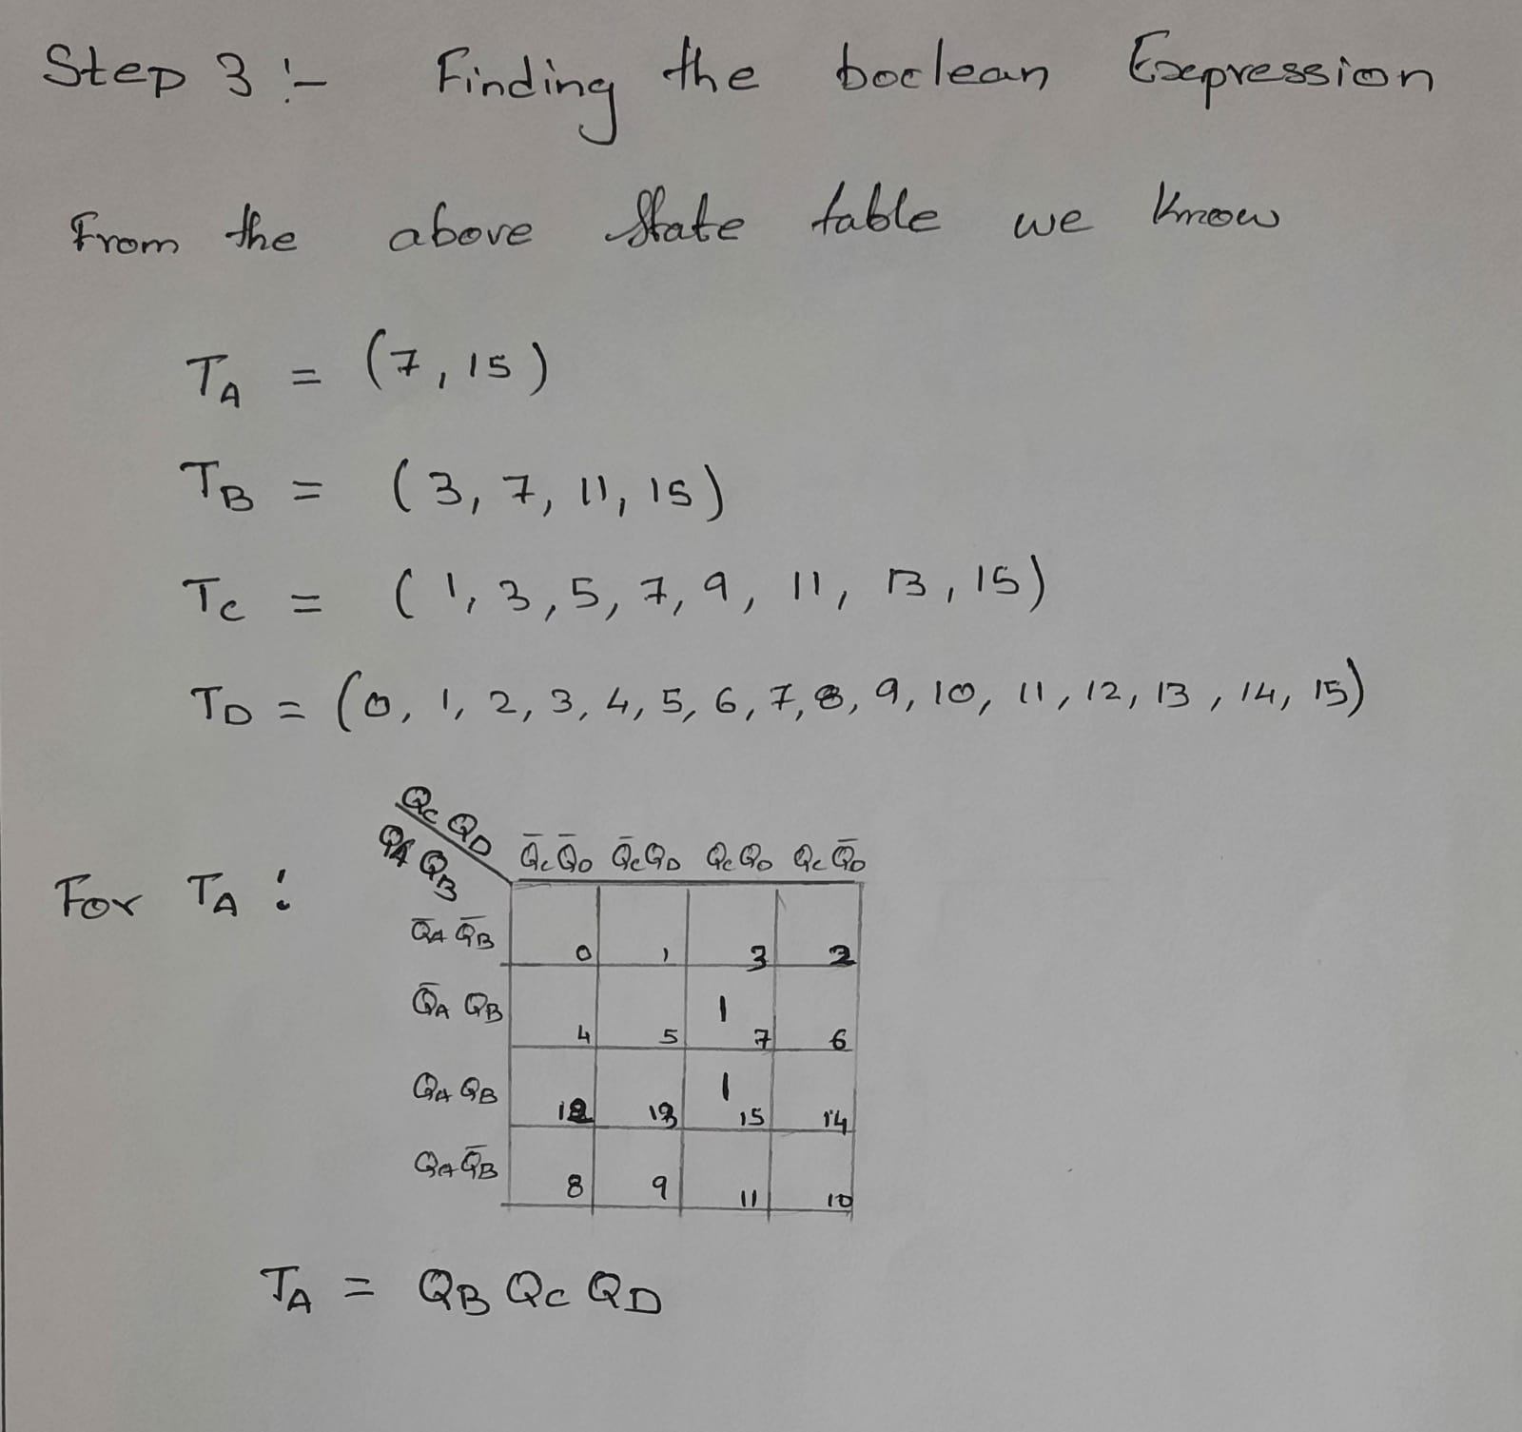

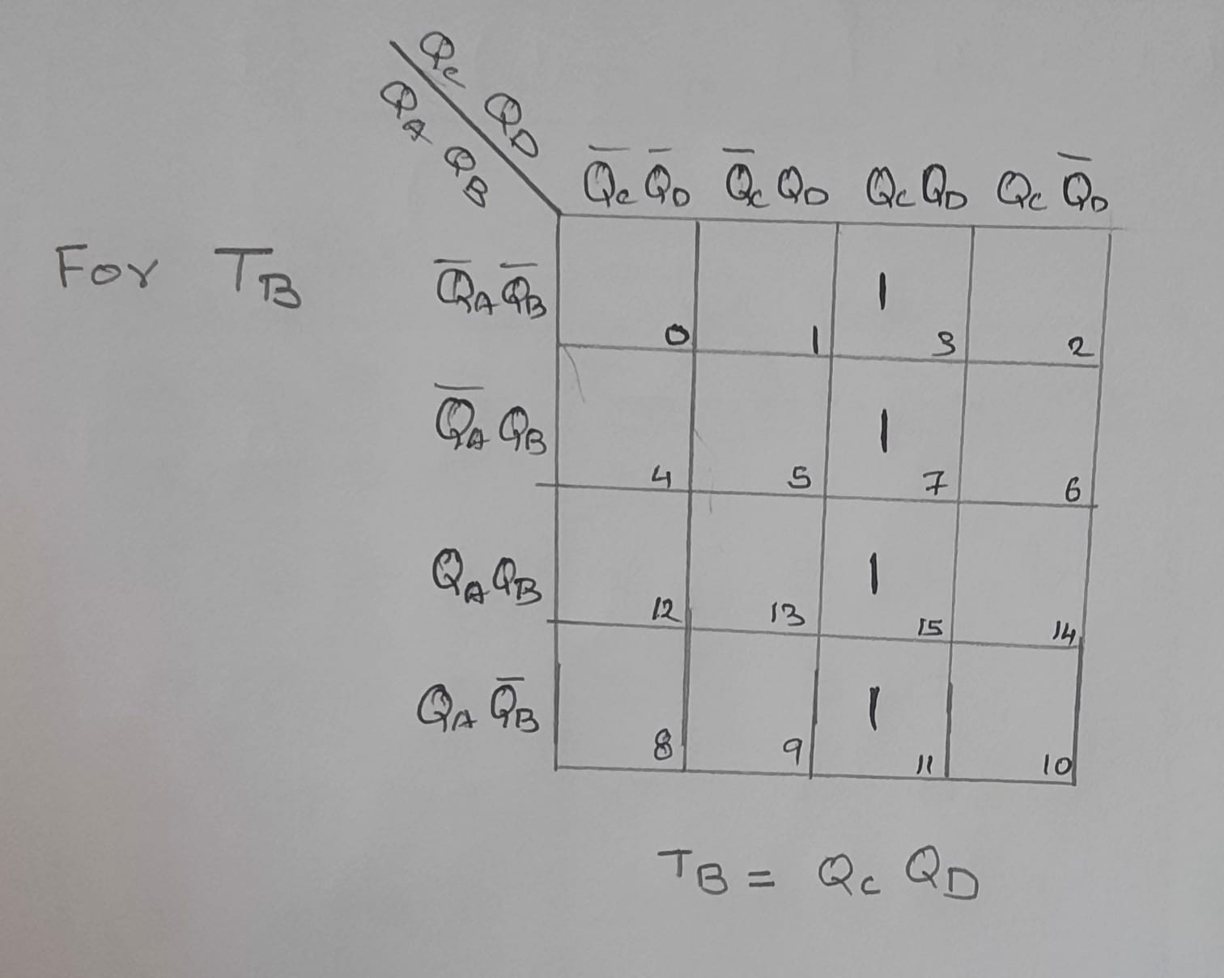

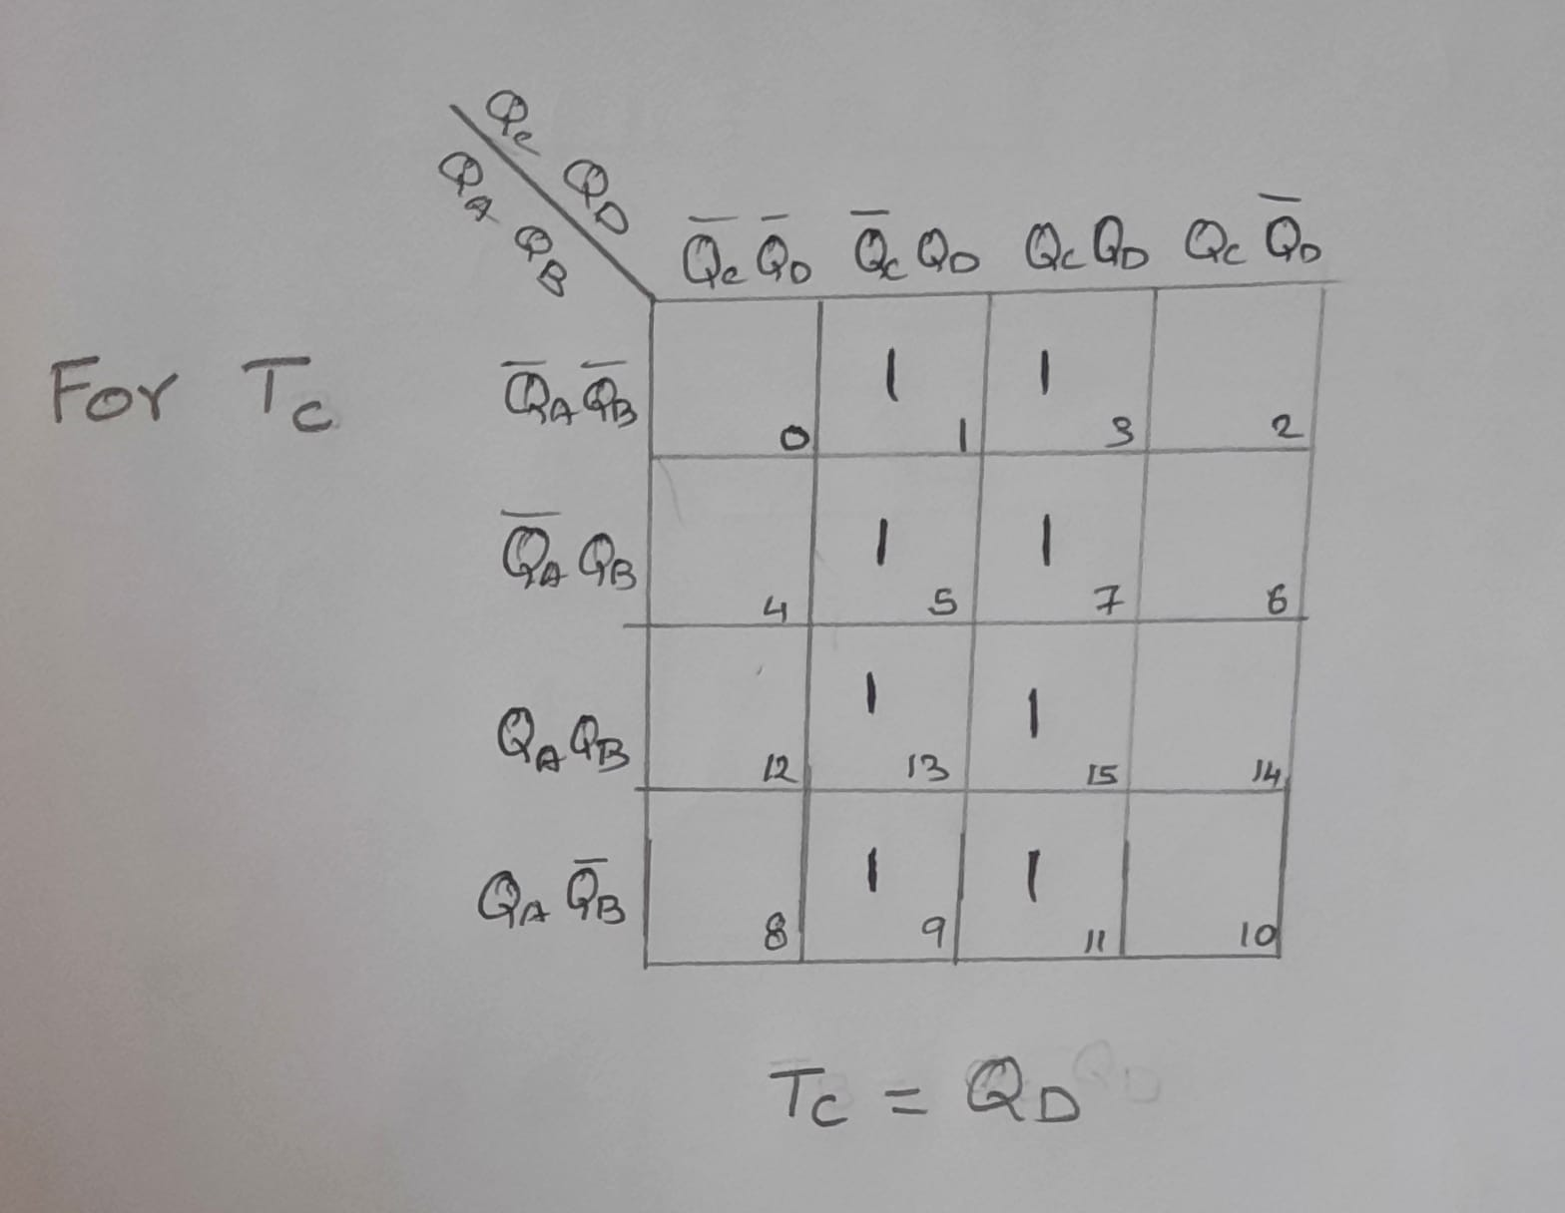

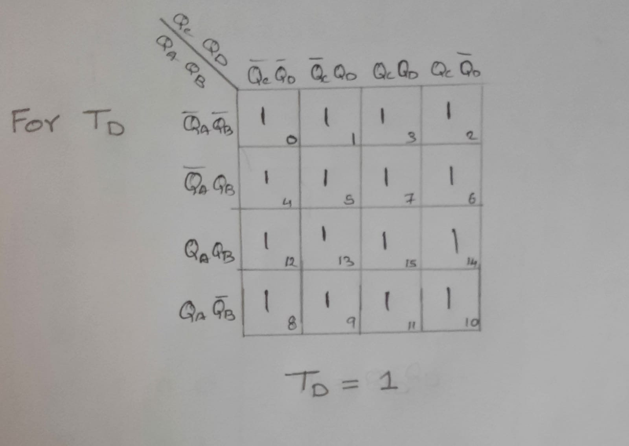

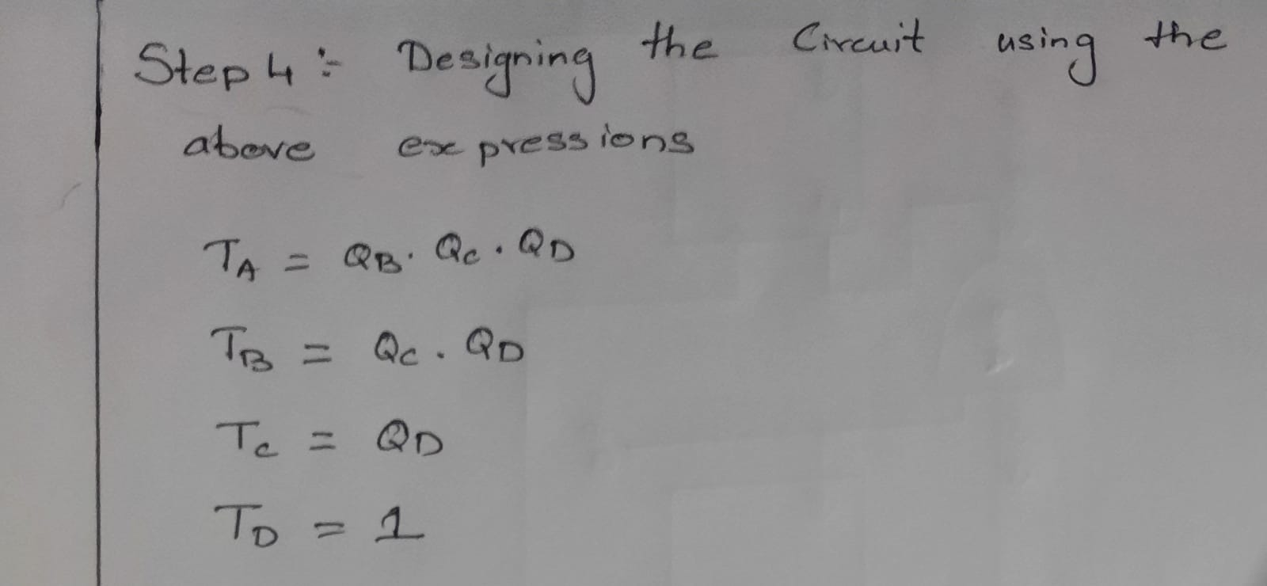

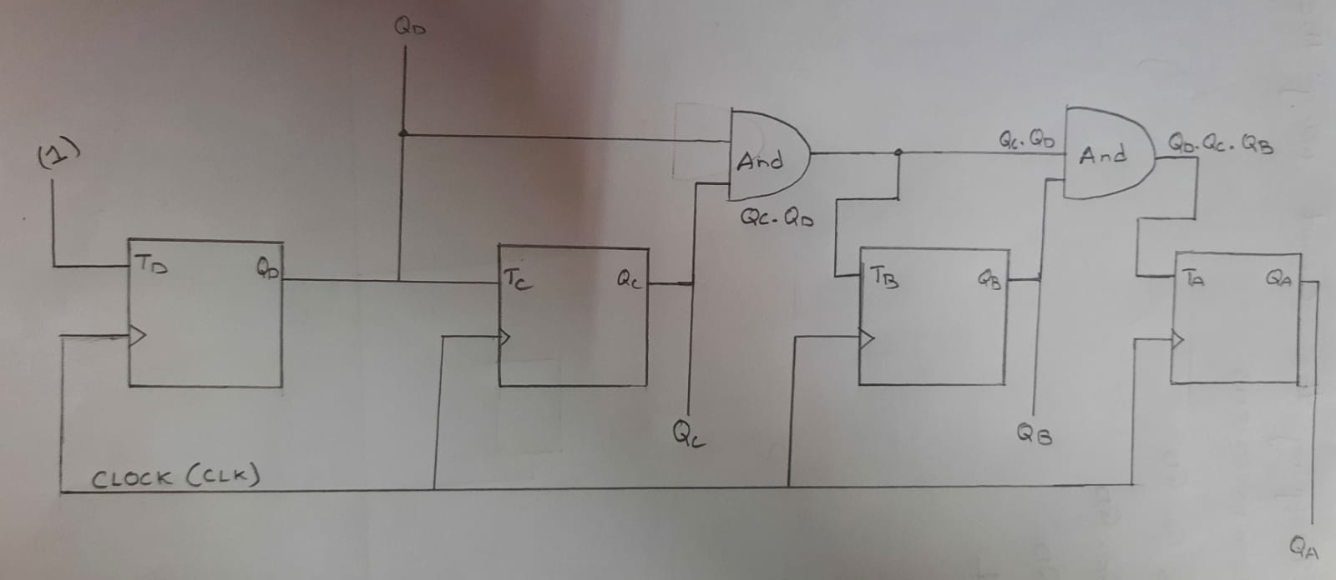

Truth Table

|  |  |  |
| --- | --- | --- |
| T | Qn | Qn+1 |
| 0 | 0 | 0 |
| 0 | 1 | 1 |
| 1 | 0 | 1 |
| 1 | 1 | 0 |

